TREND ANALYSIS OF CARDAMOM FROM 2014-2024

Sum of Sold Quantity vs. Sum of Total Quantity Arrived by Month
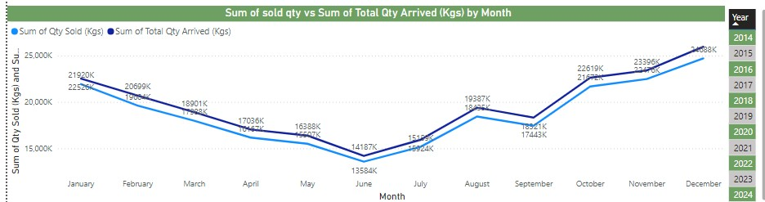

X-axis: Months from January to December.
Y-axis: Quantity in kgs
Trend
Peak Months:
January and February have high quantities sold and arrived (around 20,000-22,000 kgs).
November and December also show significant quantities (around 22,000-24,000 kgs).
Dip Months:
Quantities dip notably in June and July, with the lowest around 13,584 kgs.
Recovery:
After July, the quantities gradually rise again towards the end of the year.

Sum of Sold Quantity and Sum of Total Quantity Arrived by Year
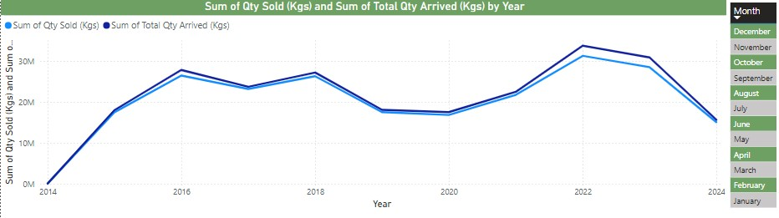

X-axis: Years from 2014 to 2024.
Y-axis: Quantity in kgs.

Trend
Rising Trend (2014-2018):
Both quantities sold and arrived increased steadily, peaking around 2018 with approximately 30 million kgs.
Fluctuations (2018-2022):
After 2018, there are fluctuations with peaks in 2020 and 2022.
These peaks indicate higher market activity or possibly higher demand in these years.
Declining Trend (2023-2024):
A noticeable decline in both quantities, suggesting reduced market activity or supply issues

Analysis
Seasonal Variations:
- The monthly trend indicates clear seasonal variations. The high quantities at the beginning and end of the year suggest these periods have higher demand or supply.
- The mid-year dip, particularly in June and July, could be due to lower production, less demand, or seasonal factors affecting supply chains.
Market Dynamics:
- The yearly trend shows that from 2014 to 2018, there was consistent growth, indicating an expanding market.
- The fluctuations post-2018 suggest volatility, possibly due to changes in market conditions, weather impacts on production, or global economic factors.
- The decline in 2023 and 2024 might indicate reduced demand, production challenges, or other market disruptions.

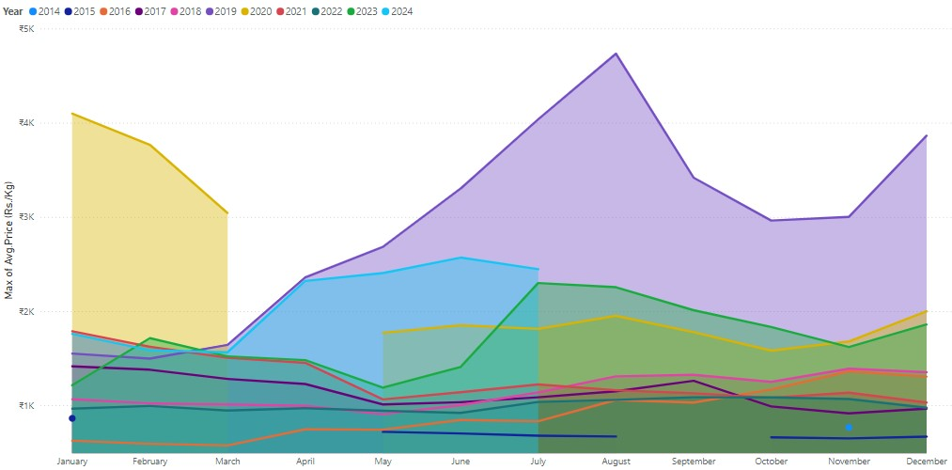
Average Price of Cardamom Over Time

X-axis: Months (January to December)
Y-axis: Average price in Rs. /Kg
Trend
Seasonal Price Peaks:
August to October: The highest prices are observed during this period. The purple area representing 2022 shows a significant spike, indicating that this year had unique market conditions leading to a sharp increase in prices.
December: Some years show a rise in prices towards the end of the year, particularly noticeable in 2024 (represented by the blue line).
Yearly Trends:
2022 (Purple Area): This year shows a prominent peak in the middle of the year, suggesting high volatility and possibly supply constraints or increased demand during this period.
2015 (Yellow Area): Early in the year, especially in February, prices were significantly higher compared to other years. This early spike might be due to factors like poor harvest or increased early-year demand.
2024 (Blue Line): Prices in 2024 start lower but show an upward trend towards December, indicating a potential market recovery or increased year-end demand.
Comparative Stability:
2016, 2023 (Thin Lines): These years show relatively stable and lower prices, indicating consistent market conditions with balanced supply and demand.
Interpretation:
- Market Dynamics: The charts indicate that cardamom prices are highly influenced by seasonal factors, with consistent peaks in late summer to early fall. This could be due to increased demand during festive seasons or reduced supply during these months.
- Yearly Variations: Significant yearly variations, like the high prices in 2022 and early 2015, suggest that certain years experience unique market conditions that disrupt the usual price trends.
- Supply and Demand: The consistent peak periods suggest that planning around these times can benefit stakeholders. Farmers and traders can maximize their revenue by targeting these peak months, while consumers might need to plan purchases accordingly to avoid higher prices.

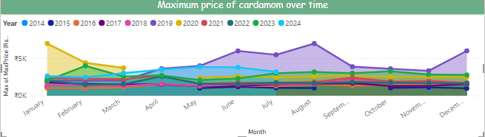
maximum price of cardamom over time

X-axis: Months (January to December)
Y-axis: Maximum price in Rs. /Kg
Seasonal Price Peaks:
- Similar to the average price trends, the maximum prices also peak around August to October.
- This indicates a consistent pattern where cardamom prices reach their highest points in late summer to early fall.
Yearly Maximum Price Variations:
- 2022: This year shows the highest peaks, particularly noticeable in August and September, indicating extreme market conditions or supply constraints.
- 2015: Early in the year, especially in February, there is a significant spike, suggesting unique market influences during this period.
- 2024: The year starts with relatively low maximum prices but shows a spike towards the end of the year, in December.
Comparative Stability:
- 2016 and 2023: These years show relatively stable maximum prices throughout the year, suggesting stable supply and demand conditions.
- 2018 to 2021: These years exhibit moderate fluctuations, with no extreme spikes, indicating balanced market conditions.
Recent Trends:
- 2024: Maximum prices in 2024 start lower compared to previous years but show an increase towards the year's end. This could indicate changing market dynamics, possibly due to new production techniques, market saturation, or other economic factors.

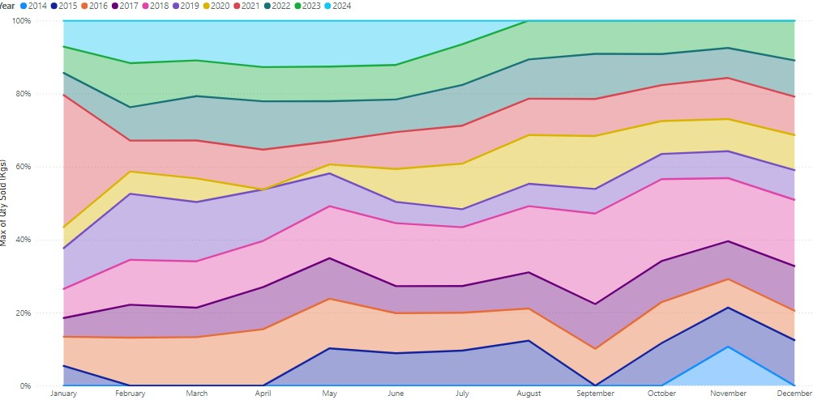

stacked area chart shows the maximum quantity of cardamom sold (in kilograms) by month for each year from 2014 to 2024. Here's a simple analysis and interpretation:
Seasonal Trends:
Sales typically peak towards the end of the year, especially from October to December.
The middle of the year (June to August) usually sees lower sales compared to the beginning and end of the year.
Yearly Comparison:
The overall quantity sold has gradually increased over the years.
The year 2024 shows the highest sales, indicating a growth trend in the cardamom market.
Earlier years like 2014 and 2015 have the smallest areas, indicating lower sales.
Monthly Patterns:
The chart suggests consistent monthly patterns across years, with some variations.
The start of the year (January and February) usually has moderate sales, followed by a dip around mid-year, and then a rise towards the year's end.
In summary, the chart indicates a growing trend in cardamom sales over the years, with a significant increase towards the end of each year.

Inflection points
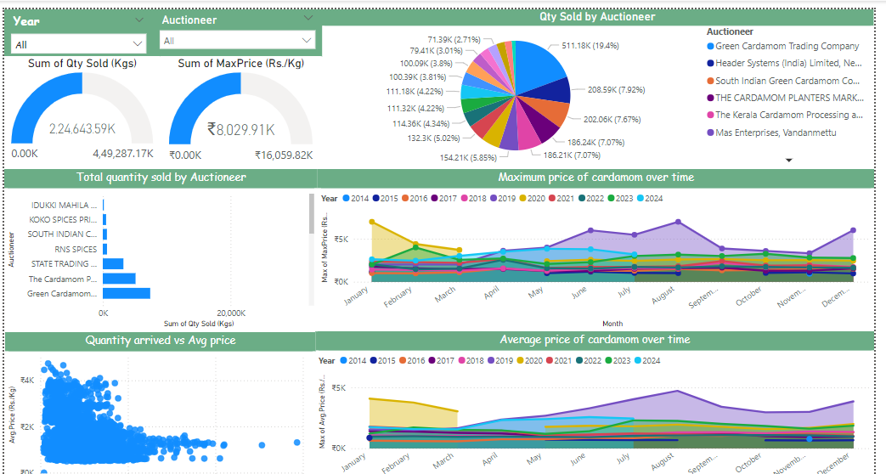

Major Auctioneers:
- Green Cardamom Trading Company: 11.18K Kgs (19.4%)
- Header Systems (India) Limited, New Delhi: 208.59K Kgs (7.92%)
- South Indian Green Cardamom Company Limited: 202.06K Kgs (7.77%)
- THE CARDAMOM PLANTERS MARKETING COOPERATIVE SOCIETY LIMITED (CPMCS): 186.24K Kgs (7.07%)
- The Kerala Cardamom Processing and Marketing Company Limited: 186.21K Kgs (7.07%)

Maximum Price of Cardamom Over Time
Inflection Points:
June: In several years (e.g., 2016, 2018, 2021), there is a noticeable rise in the maximum price around June. This suggests a potential inflection point where prices increase.
December: Another common inflection point is around December, where prices again show an upward trend.
Average Price of Cardamom Over Time
Inflection Points:
April to June: For multiple years, there's a trend of prices increasing from April to June. This indicates an inflection point where the average price shifts from stable or decreasing to increasing.
October to December: Similarly, another inflection point can be observed from October to December, where average prices often rise.
Quantity Arrived vs. Average Price
Inflection Points:
High Quantity, Low Price: A negative correlation where high quantity leads to a drop in average price. Peaks in quantity arrived often lead to dips in price.
Summary of Inflection Points:
January Peak:
Maximum Price: High at the beginning of the year, especially January.
Action: Consider selling during this peak.
February/March Decline:
Average Price: Tends to drop after a peak in February/March.
Action: Consider buying during the decline.
May/June Peak:
Maximum Price: Peaks in May/June.
Average Price: Peaks in June.
Action: Another good period for selling.
July Decline:
Average Price: Declines after peaking in June/July.
Action: Consider buying during this decline.
October to December Rise:
Maximum and Average Price: Prices rise from October and peak in December.
Action: Good time for selling.
High Supply Impact: Quantity vs Price: Larger quantities arriving in the market generally correspond to lower prices.

